An Introduction to Disease & Pathology

Lesson Overview
This is an introduction to diseases – a theme that I use throughout the year in my Human Anatomy and Physiology class. It can be split up into parts but works best to be started before and completed near the end of a histology unit. The histology portion has been left out of this lesson because it is not an essential component.
Description of Activity
Students will be pre-assessed by being asked to define the word “disease” and list as many diseases they can think of. Later, you can go back and note how many are infectious diseases, likely the majority. Next, they will read an excerpt from Gary Callahan’s book, Infection which talks about the human body being home to many more cells other than our own. This reading often provides students a first experience learning about bacteria from a beneficial perspective. Following this, students will watch excerpts from Rx for Survival to “hook” them in and to learn about the discovery of pathogens, the first vaccines, and the first global eradication project of smallpox. This will then be followed by an article put out by the National Institute of Health about diseases – how they are classified, the six major agents of infectious disease and their characteristics. At this point the lesson could be expanded to include a lab looking at different microbes under a microscope or testing the effectiveness of antibacterial agents. Finally, student will visit the Inside Cancer website to learn about pathology and epidemiology and how they related to cancer research.
Background
Disease is the result of impaired tissue function. The cause of disease can be classified into three major categories – aging, genetic and infectious. More complicated diseases, such as cancer, can be a combination of two or even all three. With the invention of the microscope, scientists were first able to describe the agents responsible for infectious diseases of which there are six categories recognized today – viruses, bacteria, fungi, protozoa, helminths, and prions. As technology advances so does our understanding of these organisms and how they act on the human body. Pathologist and epidemiologists both play an important role in identifying and fighting disease. An epidemiologist studies how and why diseases are more prevalent among certain populations while a pathologist studies cells and tissue samples to determine the cause of disease.
Goals and Objectives
Students will be able to:

- Describe the symbiotic relationships of organisms on the human body.
- Define disease and classify the cause of diseases into three major categories.
- Name and describe the general characteristics of the six types of Infectious agents to understand why different treatments are necessary for each type (classification).
- Explain how vaccines were first developed and how they build immunity.
- Explain how antibiotics were first discovered and how their over-use has led to drug resistant bacteria.
- Explain the role of epidemiologists.
- Describe the characteristics of cancer cells and tissue versus healthy tissues.

Assumptions of Prior Knowledge
Students should have a general background of cell biology.
Common Misconceptions
- Students may believe that all bacteria are harmful to the body.
- Students may believe that bacterial and viral infections can be treated in the same way.

Implementing the Lesson

Time Allotment – Variable; 20-30 minutes for Infection reading, 60 minutes for Rx for Survival video, 40+ minutes for Understanding Emerging & Re-emerging Infectious Diseases, 40 minutes for Inside Cancer website

Before Class
Photocopy student worksheets:
- Infection reading – unless you buy a class set
- Inside Cancer WebQuest
- Understanding Emerging & Re-emerging Infectious Diseases – Unless you have students read this online

During Class
Assign Infection Reading –Have students take Cornell style notes and write a summary at the end. (This can be given as homework the night before.)
Discuss the reading as a class - 5-10 minutes
Show the selected excerpts from Rx for Survival (Disease Warriors & Rise of the Superbugs) and have students fill in the answers to the questions as they go. Discuss at the end – or at the start of the next class period.
Have students read the Emerging and Re-emerging Infectious Disease article while taking notes on the 3 types of disease as well as characteristics for each of the 6 types of Infectious Agents. (Finish for homework.)
Optional (but recommended) Lab Activity: Look at different types of infectious agents under the microscope or test antibiotic agents on bacterial cultures. If you are using this to compliment a histology unit, this would be a good time to make sure students have been introduced to the different tissue types and characteristics.
Inside Cancer WebQuest – Briefly show students how to navigate the website and then have them go through the Causes and Prevention tab to answer the questions on the worksheet. Consider having them draw microscope drawings with labels of both healthy tissue samples and cancerous tissue samples.

Recommendations for Evaluation:

Give students pictures of healthy tissues and cancerous tissues and have them pick out the abnormal cells or label the characteristics.

Compare and contrast antibiotics with vaccines in terms of the approach to fighting disease and the agents they typically target.

Suggestions for Extended Learning
- If you are looking to use this as an opportunity to teach classification, you may choose to spend more time of the six types of infectious agents. Students may do additional research on the characteristics of each one’s cell type (or structure for viruses and prions).
- Students could grow bacteria cultures and then test which cleaning agent is most effective in killing bacteria.
- Students could bring in news articles and classify them as a class.
- Students could look for particular infectious agents under the microscope.

Glossary
Antigen – a molecule recognized by the immune system, often in the membranes of cellular organisms or coat of viruses
Antibody –proteins found in the blood, lymph or tissue fluid used by the immune system to recognize and attack foreign antigens
Antibiotic –a substance used to kill bacteria (sometimes protists or fungi also) or inhibit their growth
Epidemiology – the study of factors affecting the health and illness of populations
Pathologists - one who interprets and diagnoses the changes caused by disease in tissues and body fluids
Prions – an infectious agent made of a faulty protein which infects the host by denaturing its proteins
Vaccine – a material containing antigens to build immunity toward a disease
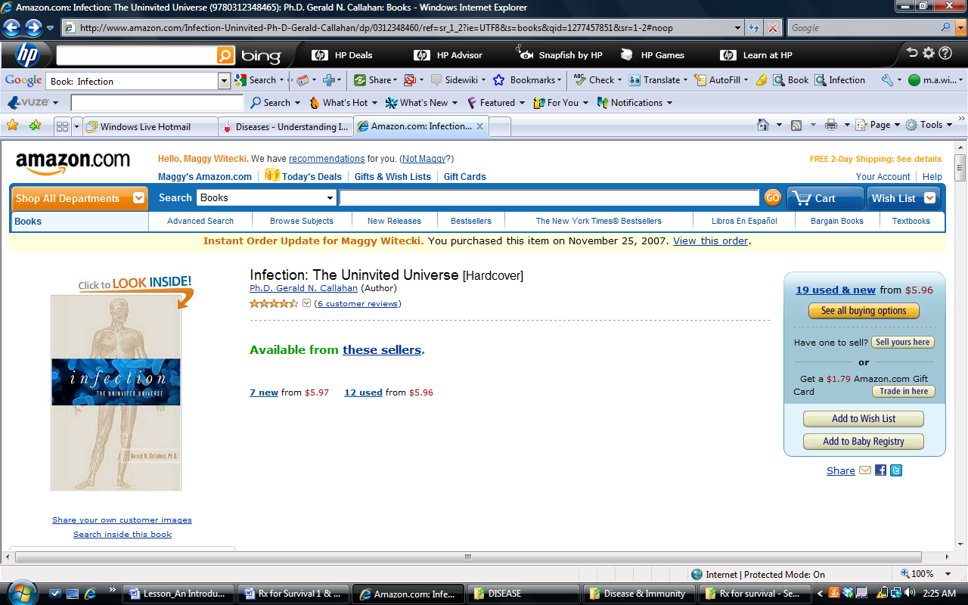
Resources:
- Infection –The Uninvited Universe - By David Callahan Nov. 28, 2006

- Rx for Survival – Jacob Gaffney, Julia Joyce, Brad Pitt, and Trevor White (DVD - 2006)
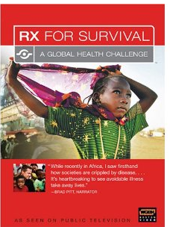

- National Institute of Health – Understanding Emerging and Re-emerging Infectious Diseases
This reading is taken from the teacher’s guide and can be found at: http://science.education.nih.gov/supplements/nih1/diseases/guide/understanding1.htm
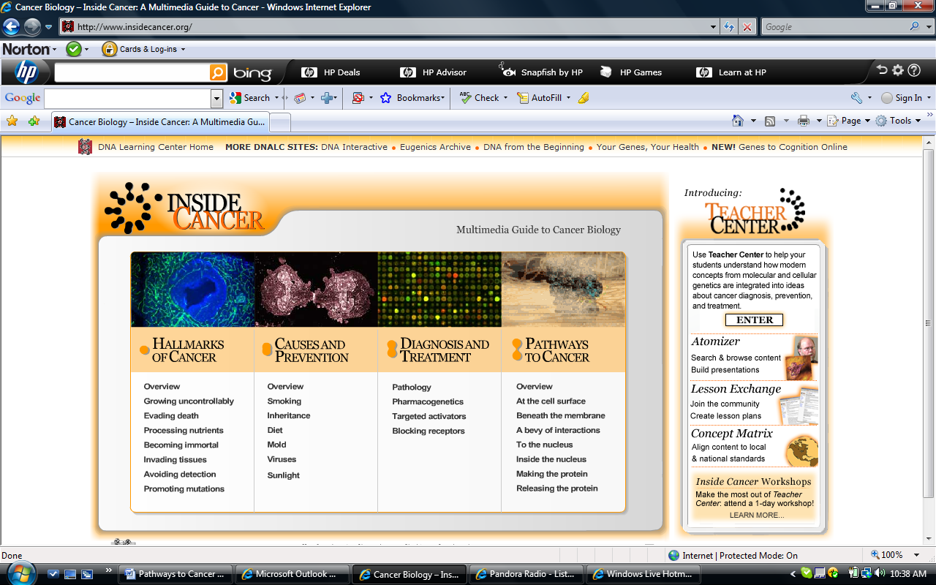

- Website- Inside cancer www.insidecancer.org

Name ______________________________________________________________ Per. _____
Rx for Survival – Video Questions
Excerpts from: Disease Warriors & Rise of the Superbugs

- Where is the last “reservoir” for the Polio virus?
- What does a virus look like? (besides microscopic)

- In 1864, what did Lois Pasteur discover?
- Who discovered the first vaccine?
- How did ‘vaccine’ get its name?
- Explain how this early vaccination process worked.

- Vaccines contain _________ viruses, so the _______________ system usually wins.
- How do antibodies work on a virus?

- What do killer T cells do if the virus gets into a cell?
- What is herd immunity?

- How did vaccination rings play a role in eradicating smallpox?

- Explain cultural resistance to vaccinations.

- Why do populations resisting vaccinations pose a risk for others?
Disc 2 -Rise of the Superbugs*
- What was the 1st antibiotic?
- How was it discovered?

- How did this antibiotic (& many others) work?

- What is ‘antibiotic resistance’ or ‘drug resistance’ and what is contributing to it?

- What does MDRTB stand for?
- Name 2 reasons it is difficult to treat.

- What are MRSA bacteria and who do they infect?

Name _______________________________________ Period ______ Date _______
Inside Cancer Web Quest
Part I - Directions: Go to www.insidecancer.org and click on the Causes and Prevention tab. Navigate through the Overview section to answer the following questions.
- What is the role of an epidemiologist?

- Exploring epidemiology: Fill out the table below to show the major factors contributing to increased rates of each of the following cancers in particular areas. Then classify the primary cause(s) of this type of cancer: aging, genetic, or infectious.
Cancer Type | Major Factors | Aging/genetic/Infectious
Lung
Liver
Stomach
Skin
Breast
Cervix
Colon/Rectum

- Does our classification system for diseases seem complete? Why or why not? What other category might you suggest?

- Navigate through the website for any additional information to support the idea that cancer can be considered a disease of aging, genetics, and infectious disease. Give a specific example for each one.
Part II. Pathology
Direction: Navigate through the Diagnosis and Treatment section to answer the following questions for each section.
- Define pathology.

- List, in order, the steps taken to determine if the specimen removed during surgery is cancerous.

- Distinguish between a surgical pathologist and a cytopathologist. Describe how a cytopathologist obtains a sample for analysis.

- When looking at a specimen under the microscopic, what two things does a pathologist look for to determine if the tissue is abnormal?
      - ______________________________________________
      - ______________________________________________
- What two changes to an individual cell indicate the cell might be cancerous?
      - ______________________________________________
      - ______________________________________________

- a) What differentiates a population of normal cells from a population of cancer cells?

  - Examine the pictures below. Based on your answer to part “a,” indicate, by labeling, which pictures are of normal cells and which show cancer cells.

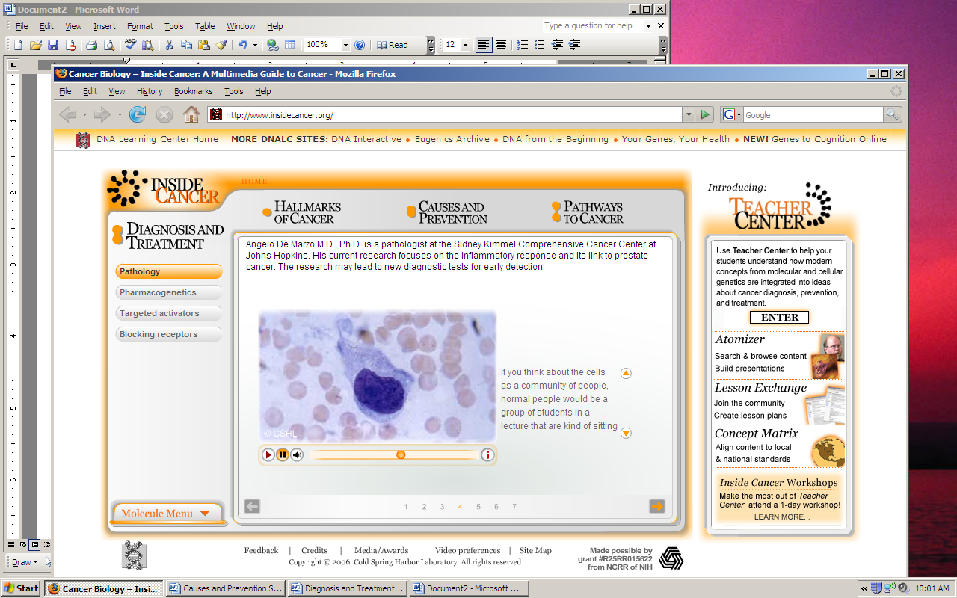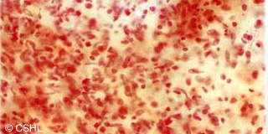

1. _______________________________ 2. _____________________________
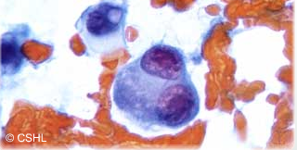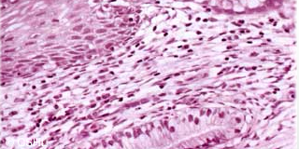
3. ________________________________ 4. _______________________________

Teacher Answer Keys
Name ______________________________________________________________ Per. _____
Rx for Survival – Video Questions
Excerpts from: Disease Warriors & Rise of the Superbugs

- Where is the last “reservoir” for the Polio virus? India
- What does a virus look like? (besides microscopic)
A piece of DNA or RNA wrapped in a protein coat
- In 1864, what did Lois Pasteur discover? Microbes - germs
- Who discovered the first vaccine? Edward Jenner
- How did ‘vaccine’ get its name? vaccinus a is latin for from a cow, the first vaccine was made using pus from a cowpox victim
- Explain how this early vaccination process worked. Pus from the scars of patients with cowpox could be placed into a small cut on the person needed to be vaccinated
- Vaccines contain weak viruses, so the immune system usually wins.
- How do antibodies work on a virus?
They bind to it and signal to other cells to destroy it.
- What do killer T cells do if the virus gets into a cell?
Destroy it
- What is herd immunity?
When unimmunized individuals are partially protected against a disease because many people around them are vaccinated reducing the spread of the diseaset
- How did vaccination rings play a role in eradicating smallpox?
The vaccination teams could not reach everyone in rural areas so they searched for cases of smallpox and then vaccinated all the individuals in that area.
- Explain cultural resistance to vaccinations.
Many people have made false correlations of the vaccine believing that it could cause impotence . They also may put their faith in God rather than trust the medicine.
- Why do populations resisting vaccinations pose a risk for others?
They can be potential carriers allowing the disease to persist in the population
Disc 2 -Rise of the Superbugs*
- What was the 1st antibiotic? Penicillin
- How was it discovered?
Petri dishes left out showed an unintended growing mold killing the bacteria
- How did this antibiotic (& many others) work?
It interferes with the production of the bacteria’s cell walls, inhibiting further growth of bacteria
- What is ‘antibiotic resistance’ or ‘drug resistance’ and what is contributing to it?
These are bacteria that can no longer be killed by drugs (antibiotics), it is contributing to the generation of super bacteria that do not respond to drug treatment.
- What does MDRTB stand for? Multi-Drug Resistant Tuberculosis
- Name 2 reasons it is difficult to treat. It is expensive, it is time consuming, it requires many drugs multiple times a day, etc.

- What are MRSA bacteria and who do they infect?
Methicillin-resistant Staphylococcus aureus and they can infect anyone – here they show high school athletes – people hospitalized are particularly susceptible because of compromised immune systems, open wounds, invasive techniques, etc.

Name _______________________________________ Period ______ Date _______
Inside Cancer Web Quest – Teacher Answer Key
Part I - Directions: Go to www.insidecancer.org and click on the Causes and Prevention tab. Navigate through the Overview section to answer the following questions.
- What is the role of an epidemiologist?
To study factors common to people in certain regions that may be responsible for disease (such as cancer)

- Exploring epidemiology: Fill out the table below to show the major factors contributing to increased rates of each of the following cancers in particular areas. Then classify the primary cause(s) of this type of cancer: aging, genetic, or infectious.
Cancer Type | Major Factors | Aging/genetic/Infectious
Lung | Smoking | Aging – Exposure
Liver | Hepatitis B virus & aflatoxin | Infectious
Stomach | Diet | Aging – exposure
Skin | Sun exposure in fair skin | Aging –exposure, genetic
Breast | Estrogen lifetime exposure | Aging, genetic
Cervix | High incidence of STI (HPV), low routine health | Infectious, aging
Colon/Rectum | High-fat/low-fiber diet | Aging - exposure
- Does our classification system for diseases seem complete? Why or why not? What other category might you suggest?
Students might have a difficult time considering lifestyles as part of the aging category –an EXPOSURE category seems like a better fit or a subcategory of aging because many lifestyle choices can help prevent cancer such as UV exposure, diet, smoking, exposure to other chemicals, etc.

- Navigate through the website for any additional information to support the idea that cancer can be considered a disease of aging, genetics, and infectious disease. Give a specific example for each one.
Student answers may vary – breast = genetic & aging, cervical – infectious & aging, etc.

Part II. Pathology
- Define pathology.
Pathology is the study of disease
- List, in order, the steps taken to determine if the specimen removed during surgery is cancerous.
      - Remove the specimen surgically
      - Take the specimen to pathology
      - Specimen is sliced into pieces for viewing under the microscope
      - Surgical pathologist views specimen for diagnosis
- Distinguish between a surgical pathologist and a cytopathologist. Describe how a cytopathologist obtains a sample for analysis.
Surgical pathologists examine whole tissues, while ctyopathologists look at individual cells. The cytopathologist obtains samples by inserting a needle into a tissue or lesion and extracting individual cells. These cells are then smeared on a microscope slide for examination.
- When looking at a specimen under the microscopic, what two things does a pathologist look for to determine if the tissue is abnormal?
      - __Architecture of the cell – how the cells are arranged
      - __Size and Shape of the cells____________________
- What two changes to an individual cell indicate the cell might be cancerous?
      - ______Increase in size of nucleus______________
      - ___Change in shape of nucleus and cell body_

- a) What differentiates a population of normal cells from a population of cancer cells?
Normal cells are arranged in an orderly fashion, while cancer cells are disorganized. In addition, in cancerous tissue you will often observe cells of various shape and size in the same area. In normal tissue all cells appear uniform in shape and size.

  - Examine the pictures below. Based on your answer to part “a,” indicate, by labeling, which pictures are of normal cells and which show cancer cells.

1. __________Cancer_______________ 2. ___________Cancer_____________
3. __________ Cancer______________ 4. ____________ Normal___________

